Computational Lexicon

What is Computational Lexicon
# Source: AI Source: Provided by: [Data Path: Persons Table -> ID Column: 1, Name_En Column: Motasem Essam] -> From: [Chatgpt (GPT-4-turbo)] on [7/29/2025]
A Computational Lexicon is a machine-readable collection of lexical entries designed for use in natural language processing (NLP), computational linguistics, and artificial intelligence. Unlike a dictionary for humans, a computational lexicon provides structured, often formally encoded linguistic data that software can process automatically.

🔹 Key Features of Computational Lexicons
# Source: AI Source: Provided by: [Data Path: Persons Table -> ID Column: 1, Name_En Column: Motasem Essam] -> From: [Chatgpt (GPT-4-turbo)] on [7/29/2025]
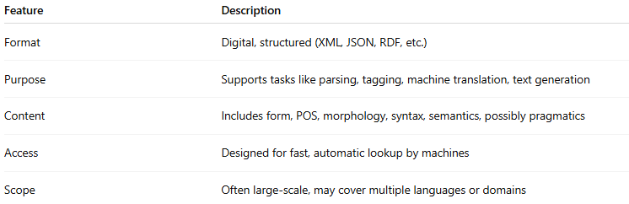
Feature | Description
Format | Digital, structured (XML, JSON, RDF, etc.)
Purpose | Supports tasks like parsing, tagging, machine translation, text generation
Content | Includes form, POS, morphology, syntax, semantics, possibly pragmatics
Access | Designed for fast, automatic lookup by machines
Scope | Often large-scale, may cover multiple languages or domains

🔹 What Does a Computational Lexicon Include?
# Source: AI Source: Provided by: [Data Path: Persons Table -> ID Column: 1, Name_En Column: Motasem Essam] -> From: [Chatgpt (GPT-4-turbo)] on [7/29/2025]
A computational lexicon contains rich linguistic annotations such as:
- Lemma: base form of the word (e.g., run)
- Inflected forms: runs, ran, running
- Part of speech (POS): noun, verb, etc.
- Morphological info: tense, aspect, case, number, gender
- Syntactic properties: subcategorization, dependency roles
- Semantic roles: agent, patient, instrument, etc.
- Sense disambiguation: links to multiple meanings or senses
- Links to ontologies: such as WordNet, FrameNet

🔹 Examples of Computational Lexicons
# Source: AI Source: Provided by: [Data Path: Persons Table -> ID Column: 1, Name_En Column: Motasem Essam] -> From: [Chatgpt (GPT-4-turbo)] on [7/29/2025]
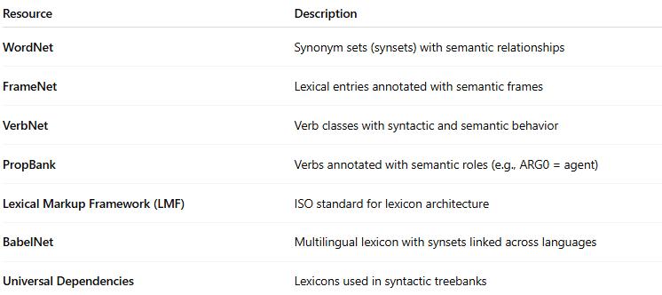
Resource | Description
WordNet | Synonym sets (synsets) with semantic relationships
FrameNet | Lexical entries annotated with semantic frames
VerbNet | Verb classes with syntactic and semantic behavior
PropBank | Verbs annotated with semantic roles (e.g., ARG0 = agent)
Lexical Markup Framework (LMF) | ISO standard for lexicon architecture
BabelNet | Multilingual lexicon with synsets linked across languages
Universal Dependencies | Lexicons used in syntactic treebanks

🔹 Sample Entry (Simplified JSON-like)
# Source: AI Source: Provided by: [Data Path: Persons Table -> ID Column: 1, Name_En Column: Motasem Essam] -> From: [Chatgpt (GPT-4-turbo)] on [7/29/2025]
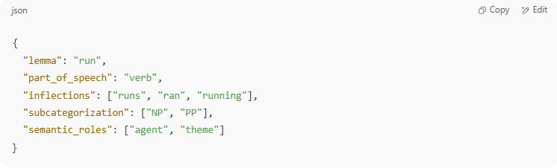
{
"lemma": "run",
"part_of_speech": "verb",
"inflections": ["runs", "ran", "running"],
"subcategorization": ["NP", "PP"],
"semantic_roles": ["agent", "theme"]
}

🔹 Computational vs Other Lexicons
# Source: AI Source: Provided by: [Data Path: Persons Table -> ID Column: 1, Name_En Column: Motasem Essam] -> From: [Chatgpt (GPT-4-turbo)] on [7/29/2025]
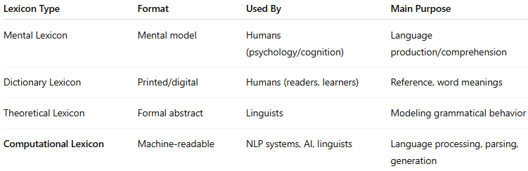
Lexicon Type | Format | Used By | Main Purpose
Mental Lexicon | Mental model | Humans (psychology/cognition) | Language production/comprehension
Dictionary Lexicon | Printed/digital | Humans (readers, learners) | Reference, word meanings
Theoretical Lexicon | Formal abstract | Linguists | Modeling grammatical behavior
Computational Lexicon | Machine-readable | NLP systems, AI, linguists | Language processing, parsing, generation

